Reading Mileage

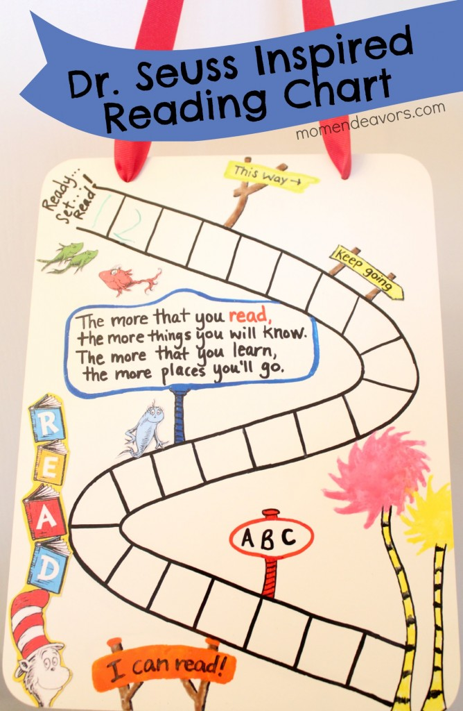
Thank you for continuing to share your child’s book with them each night. Reading “mileage” is vital for your child’s progress in reading at this stage of their development. Like any skill, reading improves with practice. Children at the Prep and Grade 1 levels of reading need to establish the early reading strategies by consistent reading of books at their instructional level, ie books that are not too easy or too hard.
Your role at this stage is to:-
- Encourage children to find 15 or more minutes of quiet time to read
- Encourage them to read the blurb of the story when choosing a book
- Encourage them to read as they would speak (with fluency and expression)
- Talk to your child about the book
- Make predictions about what the book might be about or how the story might end
- Work to or practice your child’s literacy learning goals
- Encourage your child to borrow from the library
- Please ensure their reading book is returned daily to class even if they have not completed it.
NOTE: It is not expected that chapter or lengthy books are completed in one night
Partnerships between the student, home and school will give your child the best opportunity to achieve to the best of their abilities.
If at any time you wish to discuss your child’s reading progress, please make an appointment with the class teacher.
~ Reading takes you to another place when you have to stay where you are! ~

